Indian census:

Here,we have used two datasets and found out many insights about Avg growth rate,Gender ratio,Avg literacy rate and much more.All the discoveries are mentioned below .

TECH STACK USED-MY SQL

Project overview with database “Project” and tables as “Dataset1” and “Dataset2”:

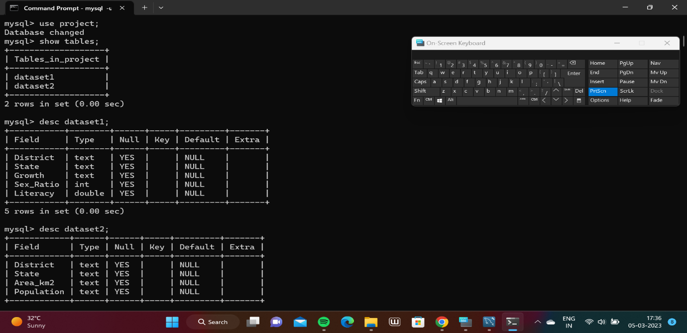

To calculate total number of rows:

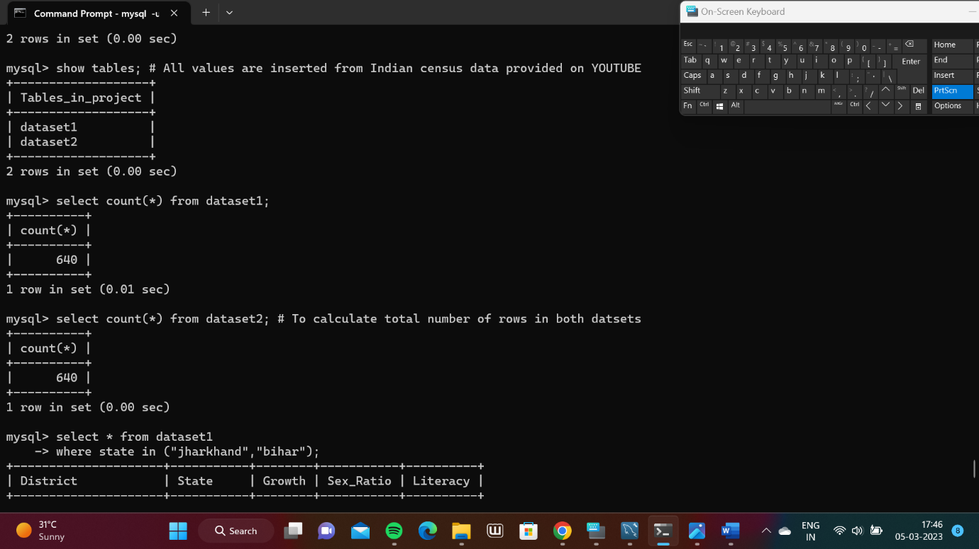

To get info of only two states:(Jharkhand and Bihar)

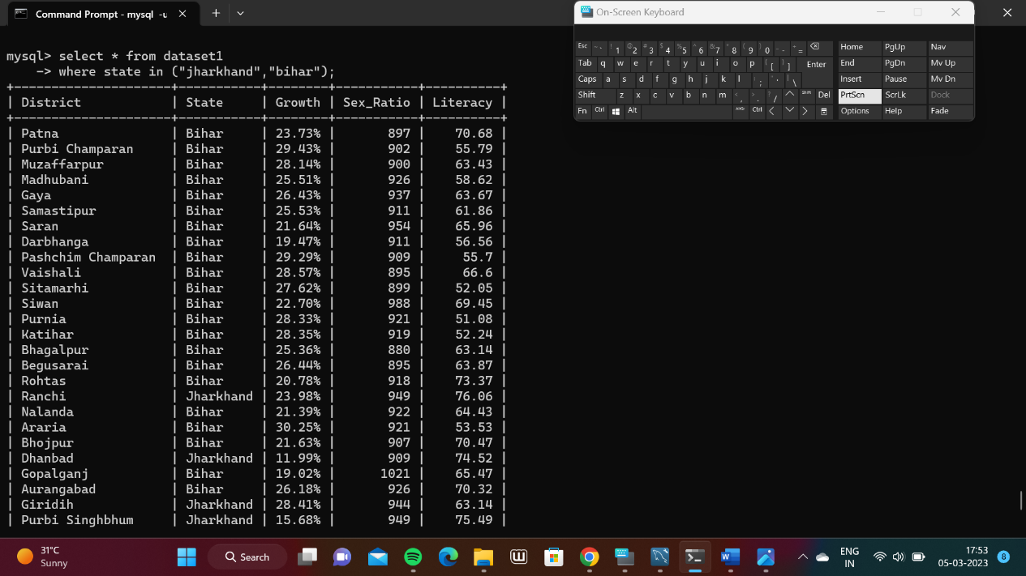

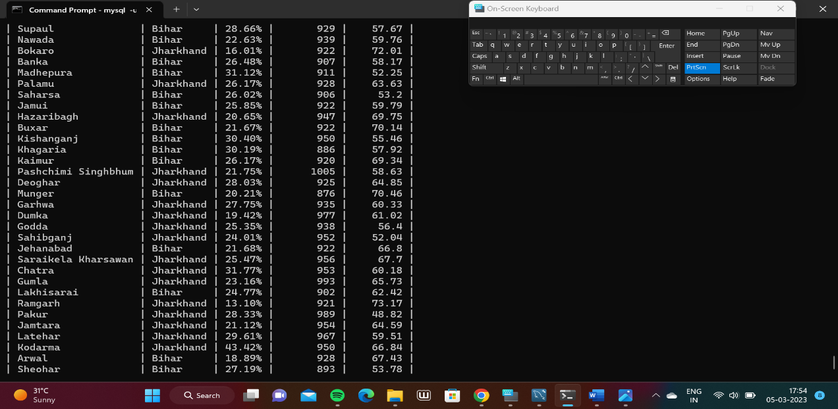

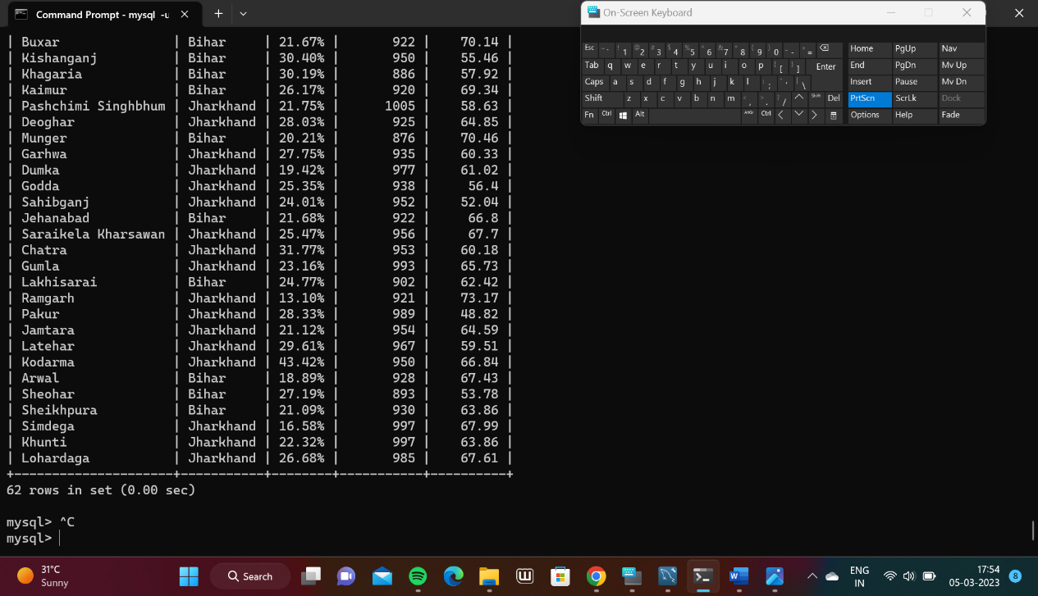

Sum of population:

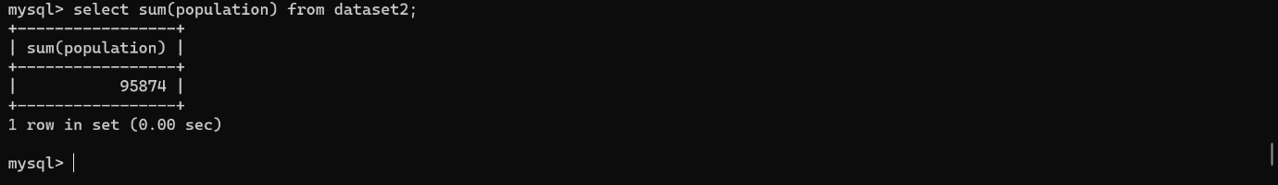

Average growth rate(India):

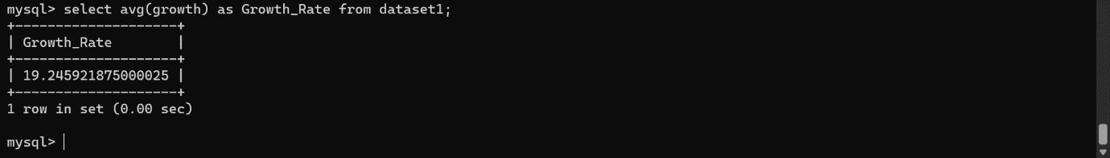

Average growth rate per state:

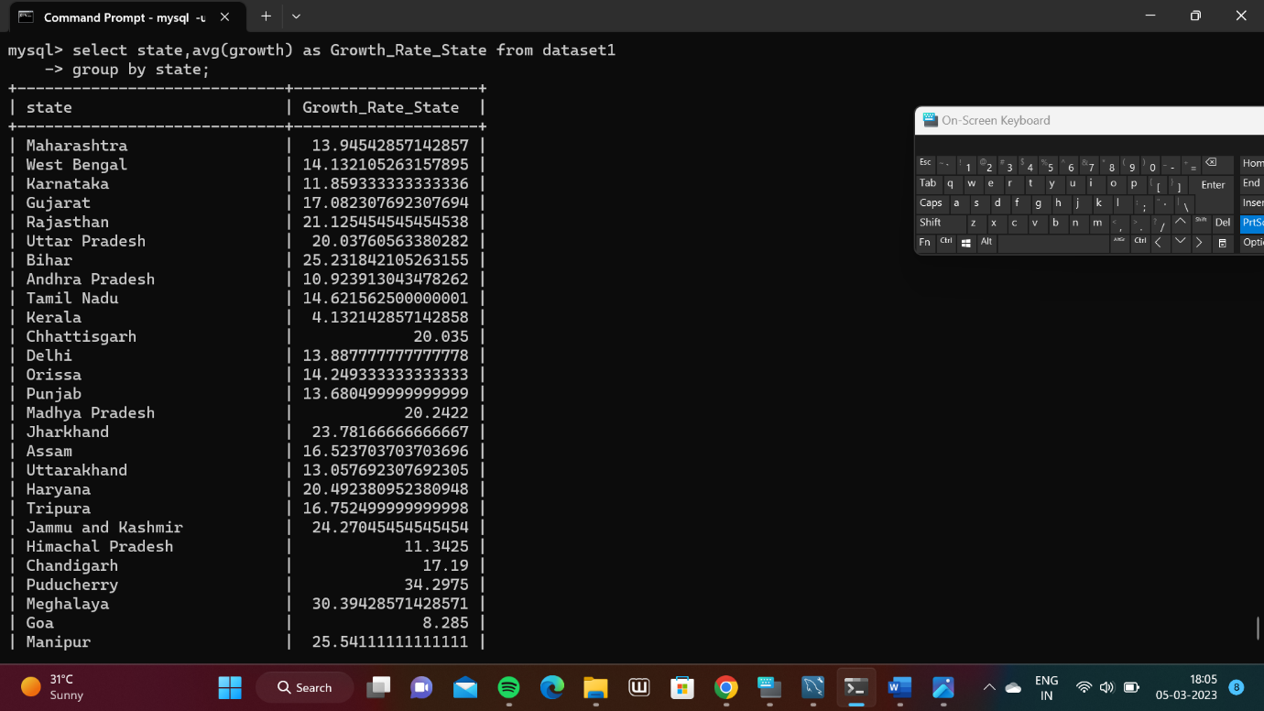

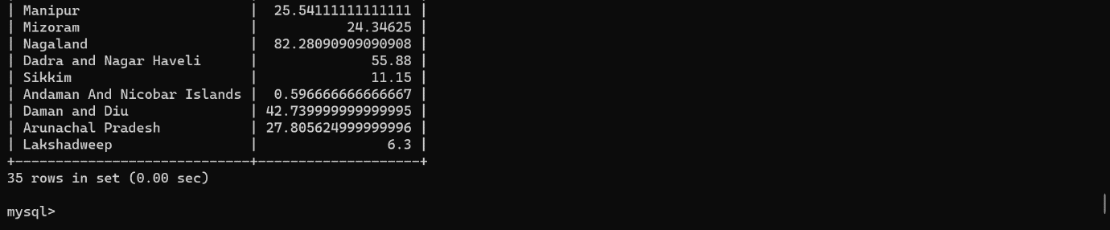

Average Sex Ratio per state:

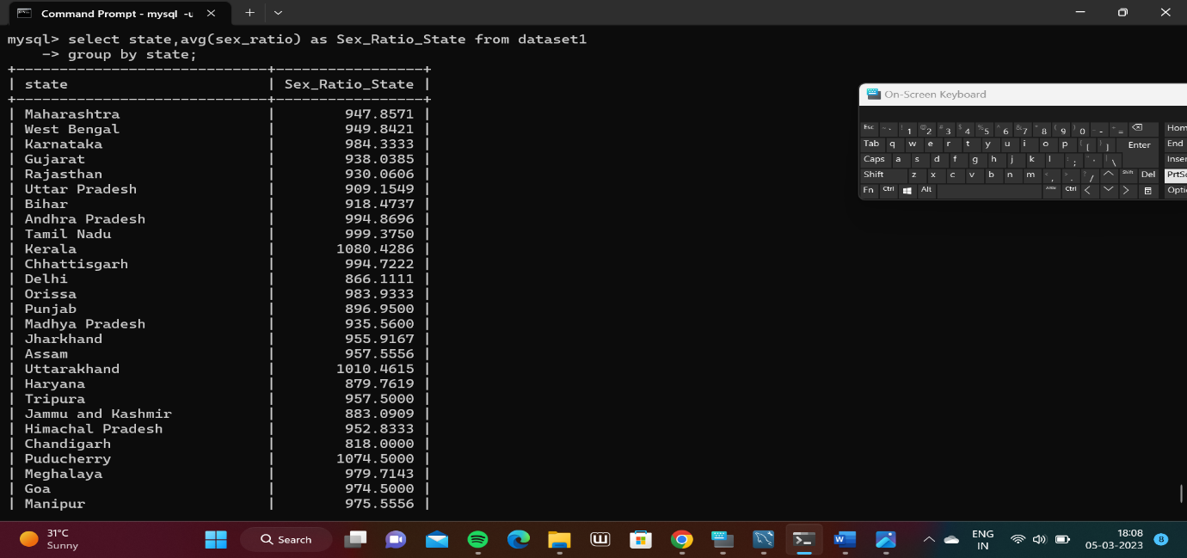

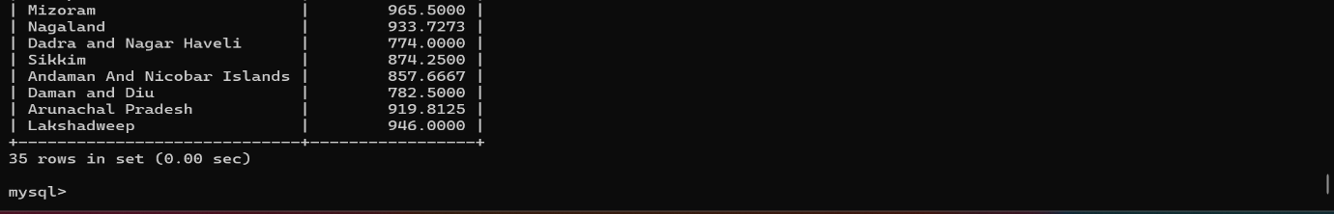

Rounding off Average sex Ratio per state :

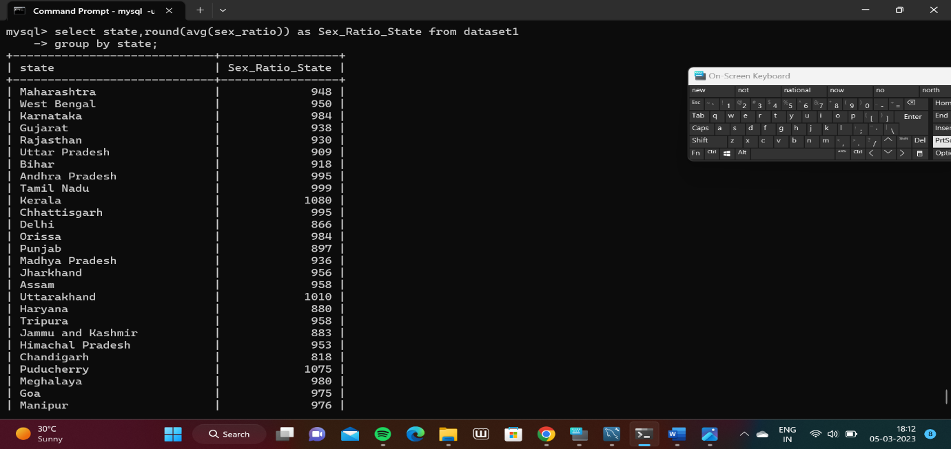

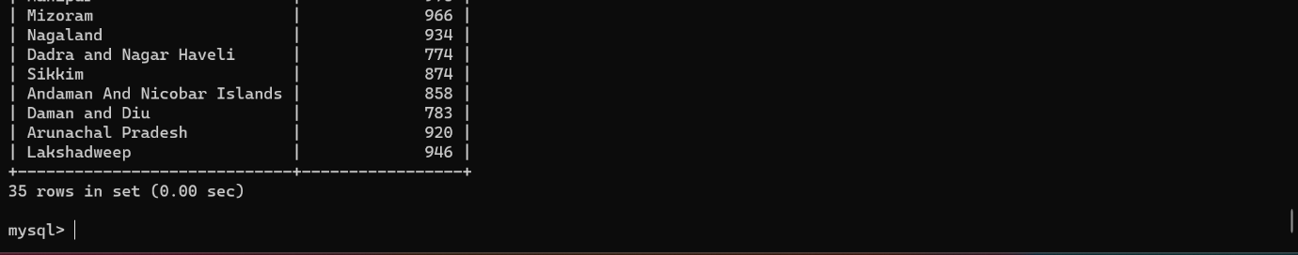

Arrange Average sex Ratio/State in alphabetical order of states:

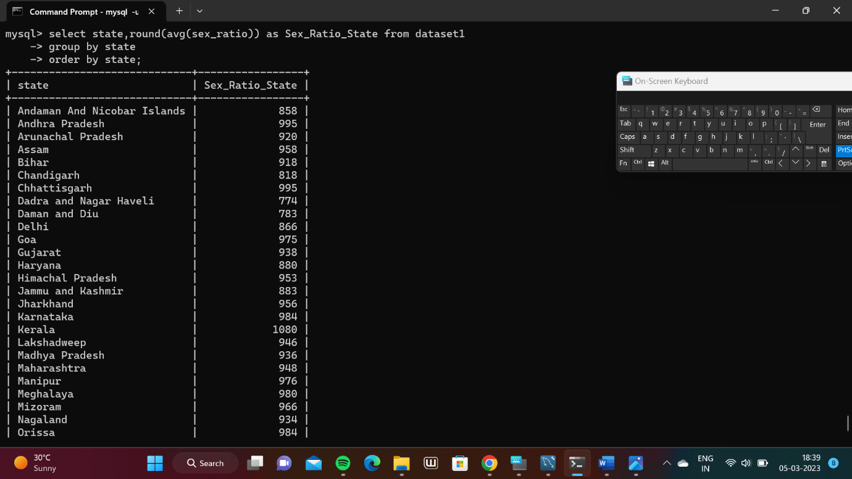

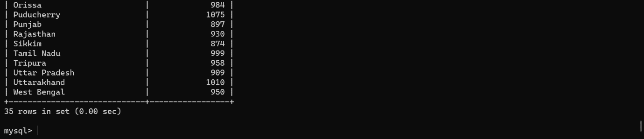

Top 3 state displaying higher Growth Rate:

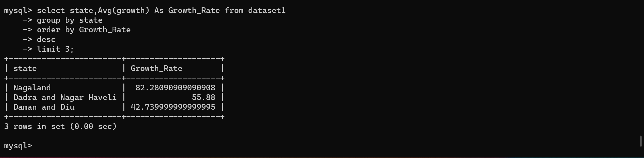

Average literacy rate per state:

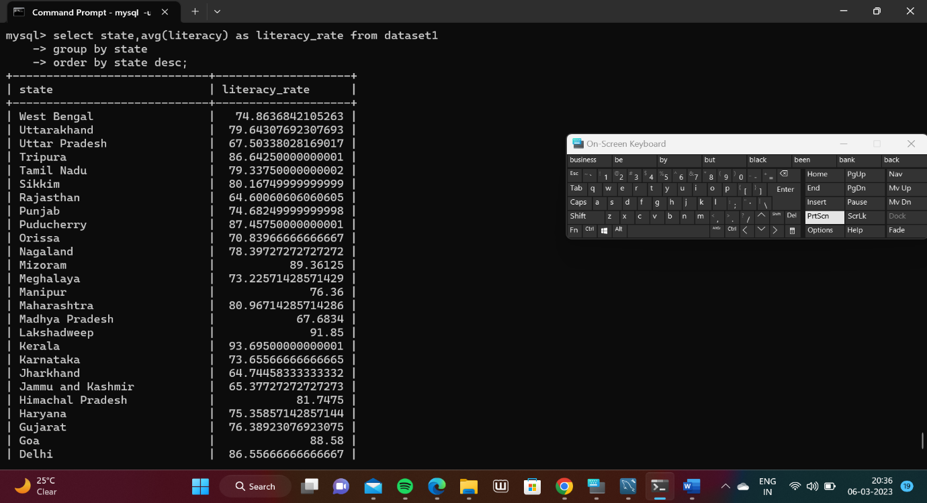

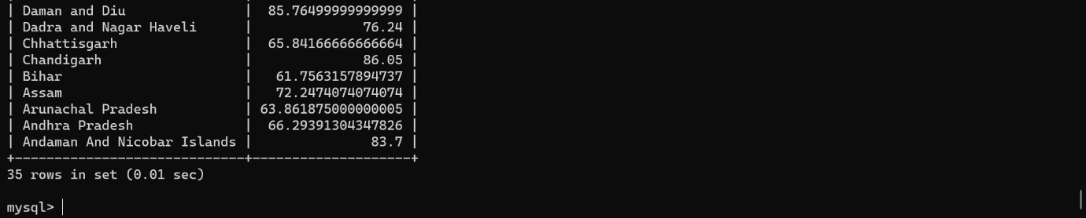

Select states where Average Literacy rate is greater than 90%:

